St. Paul’s Lutheran Chapel and University Center
Twentieth Sunday after Pentecost
October 11th, 2026
Divine Service Setting Three, Lutheran Service Book, page 184
Stand

The sign of the cross may be made by all in remembrance of their Baptism.

P In the name of the Father and of the ✠ Son and of the Holy Spirit.
C Amen.

P Beloved in the Lord! Let us draw near with a true heart and confess our sins unto God our Father, beseeching Him in the name of our Lord Jesus Christ to grant us forgiveness.

P Our help is in the name of the Lord,
C who made heaven and earth.
P I said, I will confess my transgressions unto the Lord,
C and You forgave the iniquity of my sin.

Kneel/Stand

Silence for reflection on God’s Word and for self-examination.

P O almighty God, merciful Father,
C I, a poor, miserable sinner, confess unto You all my sins and iniquities with which I have ever offended You and justly deserved Your temporal and eternal punishment. But I am heartily sorry for them and sincerely repent of them, and I pray You of Your boundless mercy and for the sake of the holy, innocent, bitter sufferings and death of Your beloved Son, Jesus Christ, to be gracious and merciful to me, a poor, sinful being.

P Upon this your confession, I, by virtue of my office, as a called and ordained servant of the Word, announce the grace of God unto all of you, and in the stead and by the command of my Lord Jesus Christ I forgive you all your sins in the name of the Father and of the T Son and of the Holy Spirit.
C Amen.

Stand

Service of the Word

514 The Bridegroom Soon Will Call Us
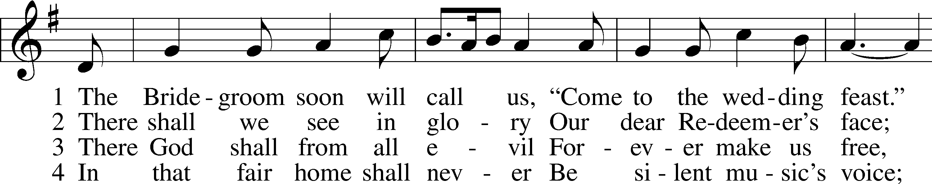
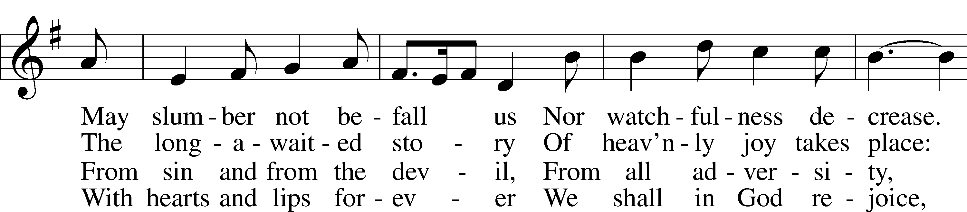
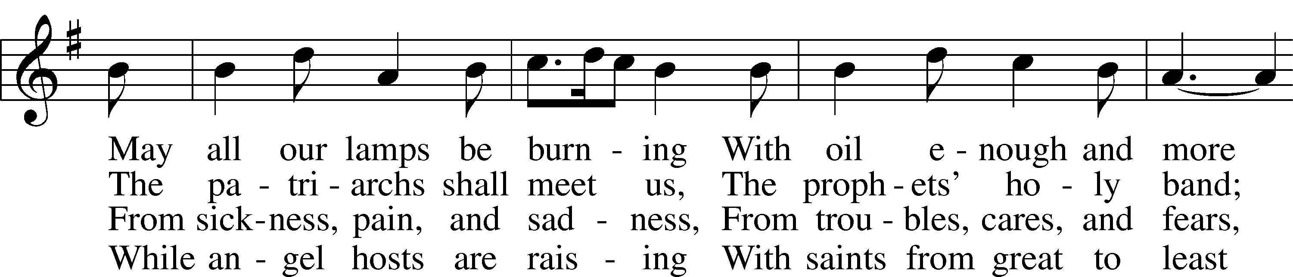
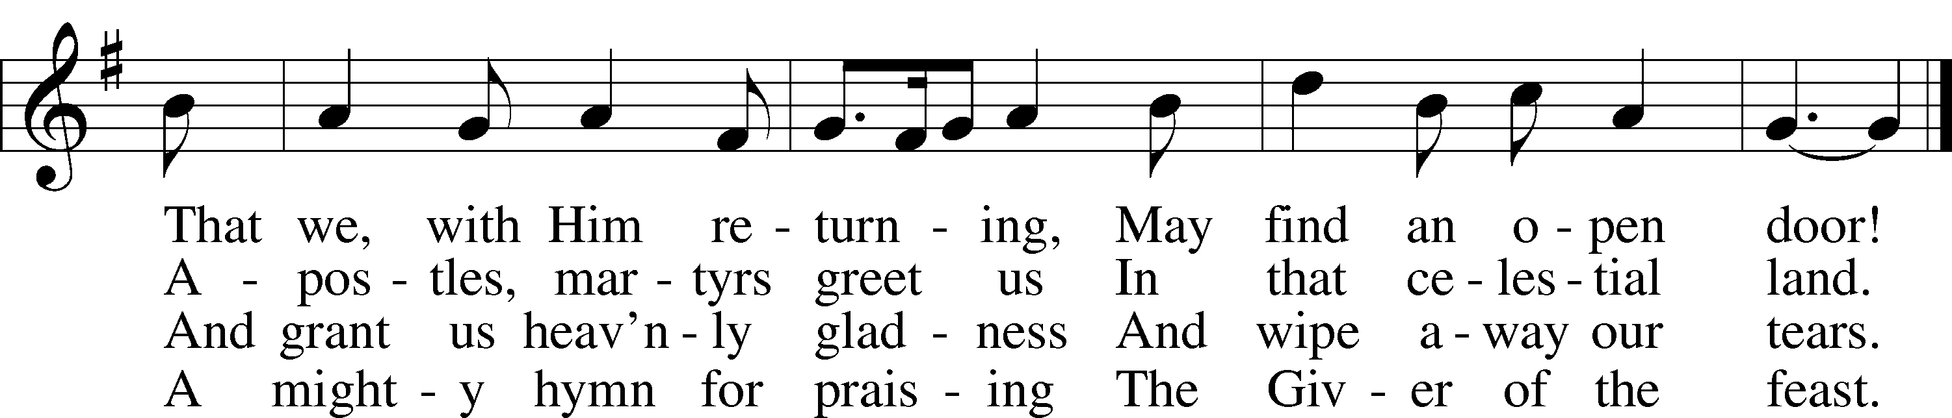
Text: Johann Walter, 1496–1570; (st. 1): tr. F. Samuel Janzow, 1913–2001; (sts. 2–4): tr. Matthias Loy, 1828–1915, alt.
Tune: Musae Sioniae, 1609, vol. 7, Wolfenbüttel, ed. Michael Praetorius
Text (st. 1): © 1982 Concordia Publishing House. Used by permission: LSB Hymn License no. 110001899
Text (sts. 2–4) and tune: Public domain

Kyrie LSB 186
C Lord, have mercy upon us.
Christ, have mercy upon us.
Lord, have mercy upon us.

Gloria in Excelsis LSB 187
P Glory be to God on high:
C and on earth peace, goodwill toward men.
We praise Thee, we bless Thee, we worship Thee,
we glorify Thee, we give thanks to Thee, for Thy great glory.
O Lord God, heav’nly King, God the Father Almighty.
O Lord, the only-begotten Son, Jesus Christ;
O Lord God, Lamb of God, Son of the Father,
that takest away the sin of the world, have mercy upon us.
Thou that takest away the sin of the world, receive our prayer.
Thou that sittest at the right hand of God the Father, have mercy upon us.
For Thou only art holy; Thou only art the Lord.
Thou only, O Christ, with the Holy Ghost,
art most high in the glory of God the Father. Amen.

Salutation and Collect of the Day
P The Lord be with you.
C And with thy spirit.

P Let us pray.
Almighty God, You invite us to trust in You for our salvation. Deal with us not in the severity of Your judgment but by the greatness of Your mercy; through Jesus Christ, Your Son, our Lord, who lives and reigns with You and the Holy Spirit, one God, now and forever.

C Amen.

Sit

Old Testament Reading Isaiah 25:6–9
6On this mountain the Lord of hosts will make for all peoples
a feast of rich food, a feast of well-aged wine,
of rich food full of marrow, of aged wine well refined.
7And he will swallow up on this mountain
the covering that is cast over all peoples,
the veil that is spread over all nations.
8He will swallow up death forever;
and the Lord God will wipe away tears from all faces,
and the reproach of his people he will take away from all the earth,
for the Lord has spoken.
9It will be said on that day,
“Behold, this is our God; we have waited for him, that he might save us.
This is the Lord; we have waited for him;
let us be glad and rejoice in his salvation.”

A This is the Word of the Lord.
C Thanks be to God.

Psalm Psalm 23; antiphon: v. 5a
1The Lord is my | shepherd;*
I | shall not want.
2He makes me lie down in green | pastures.*
He leads me beside still | waters.
3He re- | stores my soul.*
He leads me in paths of righteousness for his | name’s sake.
4Even though I walk through the valley of the shadow of death,
I will fear no evil, for you are | with me;*
your rod and your staff, they | comfort me.
5You prepare a table before me
in the presence of my | enemies;*
you anoint my head with oil;
my cup | overflows.
6Surely goodness and mercy shall follow me
all the days | of my life,*
and I shall dwell in the house of the Lord for- | ever.

Epistle Philippians 4:4–13
4Rejoice in the Lord always; again I will say, Rejoice. 5Let your reasonableness be known to everyone. The Lord is at hand; 6do not be anxious about anything, but in everything by prayer and supplication with thanksgiving let your requests be made known to God. 7And the peace of God, which surpasses all understanding, will guard your hearts and your minds in Christ Jesus.
8Finally, brothers, whatever is true, whatever is honorable, whatever is just, whatever is pure, whatever is lovely, whatever is commendable, if there is any excellence, if there is anything worthy of praise, think about these things. 9What you have learned and received and heard and seen in me—practice these things, and the God of peace will be with you.
10I rejoiced in the Lord greatly that now at length you have revived your concern for me. You were indeed concerned for me, but you had no opportunity. 11Not that I am speaking of being in need, for I have learned in whatever situation I am to be content. 12I know how to be brought low, and I know how to abound. In any and every circumstance, I have learned the secret of facing plenty and hunger, abundance and need. 13I can do all things through him who strengthens me.

A This is the Word of the Lord.
C Thanks be to God.

Stand

Alleluia LSB 190
C Alleluia. Alleluia. Alleluia.

Holy Gospel Matthew 22:1–14
P The Holy Gospel according to St. Matthew, the twenty-second chapter.
C Glory be to Thee, O Lord.

1Again Jesus spoke to them in parables, saying, 2“The kingdom of heaven may be compared to a king who gave a wedding feast for his son, 3and sent his servants to call those who were invited to the wedding feast, but they would not come. 4Again he sent other servants, saying, ‘Tell those who are invited, See, I have prepared my dinner, my oxen and my fat calves have been slaughtered, and everything is ready. Come to the wedding feast.’ 5But they paid no attention and went off, one to his farm, another to his business, 6while the rest seized his servants, treated them shamefully, and killed them. 7The king was angry, and he sent his troops and destroyed those murderers and burned their city. 8Then he said to his servants, ‘The wedding feast is ready, but those invited were not worthy. 9Go therefore to the main roads and invite to the wedding feast as many as you find.’ 10And those servants went out into the roads and gathered all whom they found, both bad and good. So the wedding hall was filled with guests.
11“But when the king came in to look at the guests, he saw there a man who had no wedding garment. 12And he said to him, ‘Friend, how did you get in here without a wedding garment?’ And he was speechless. 13Then the king said to the attendants, ‘Bind him hand and foot and cast him into the outer darkness. In that place there will be weeping and gnashing of teeth.’ 14For many are called, but few are chosen.”

P This is the Gospel of the Lord.
C Praise be to Thee, O Christ.

Nicene Creed
C I believe in one God,
the Father Almighty,
maker of heaven and earth
and of all things visible and invisible.

And in one Lord Jesus Christ,
the only-begotten Son of God,
begotten of His Father before all worlds,
God of God, Light of Light,
very God of very God,
begotten, not made,
being of one substance with the Father,
by whom all things were made;
who for us men and for our salvation came down from heaven
and was incarnate by the Holy Spirit of the virgin Mary
and was made man;
and was crucified also for us under Pontius Pilate.
He suffered and was buried.
And the third day He rose again according to the Scriptures
and ascended into heaven
and sits at the right hand of the Father.
And He will come again with glory to judge both the living and the dead,
whose kingdom will have no end.

And I believe in the Holy Spirit,
the Lord and giver of life,
who proceeds from the Father and the Son,
who with the Father and the Son together is worshiped and glorified,
who spoke by the prophets.
And I believe in one holy Christian and apostolic Church,
I acknowledge one Baptism for the remission of sins,
and I look for the resurrection of the dead
and the life T of the world to come. Amen.

Sit

510 A Multitude Comes from the East and the West
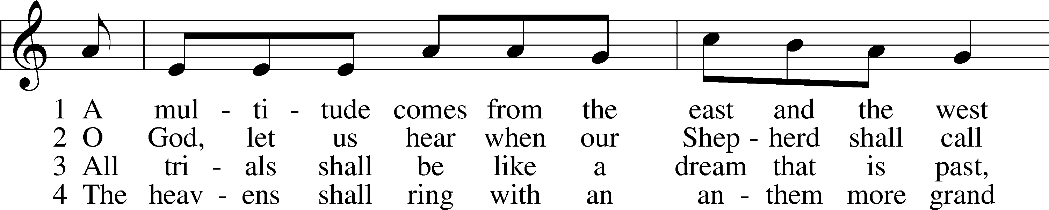
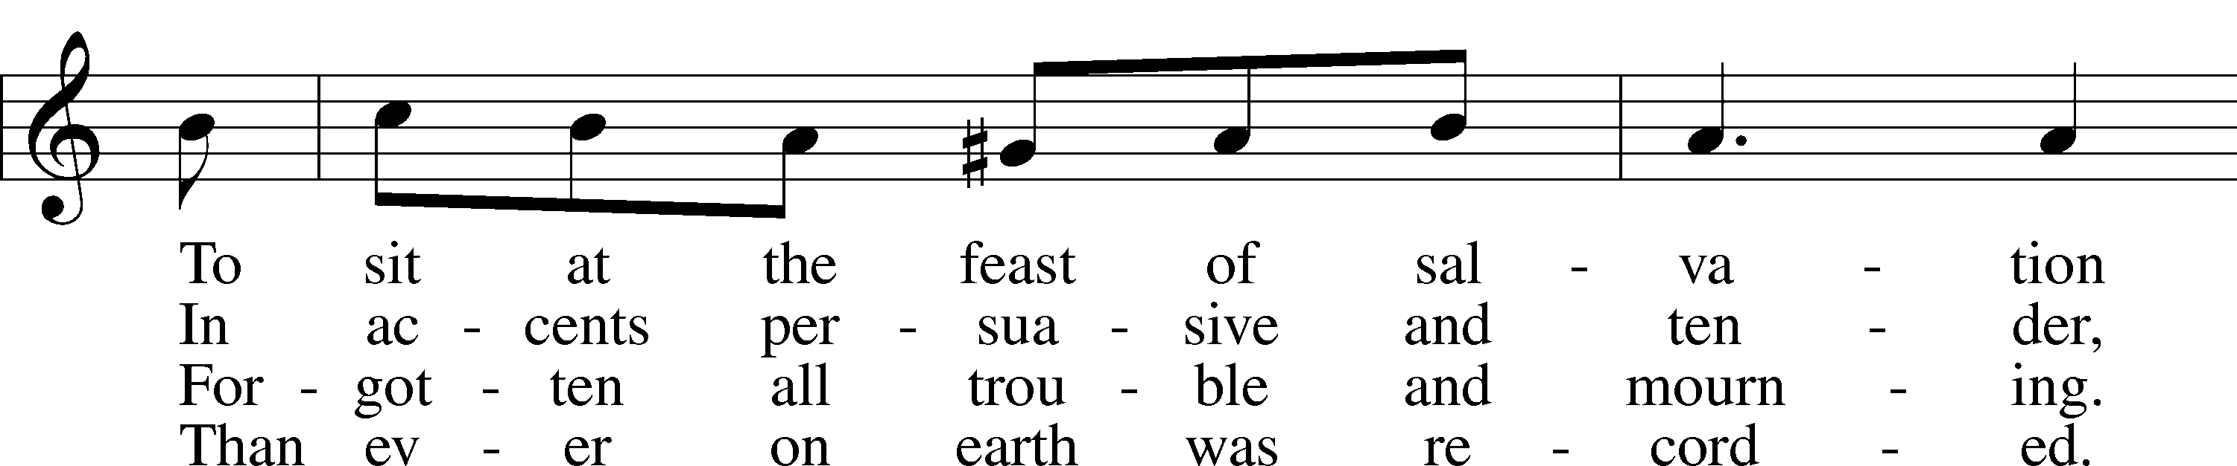
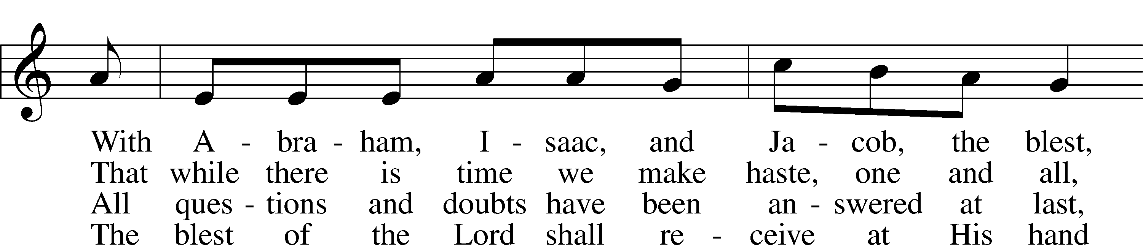
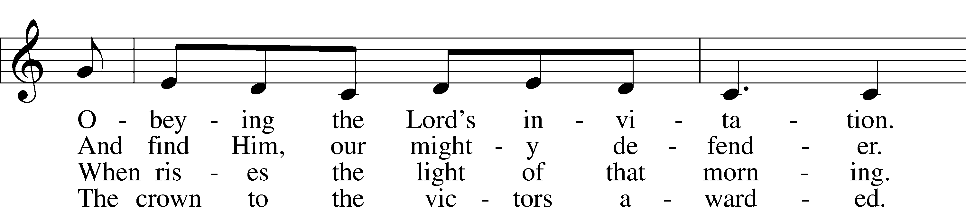
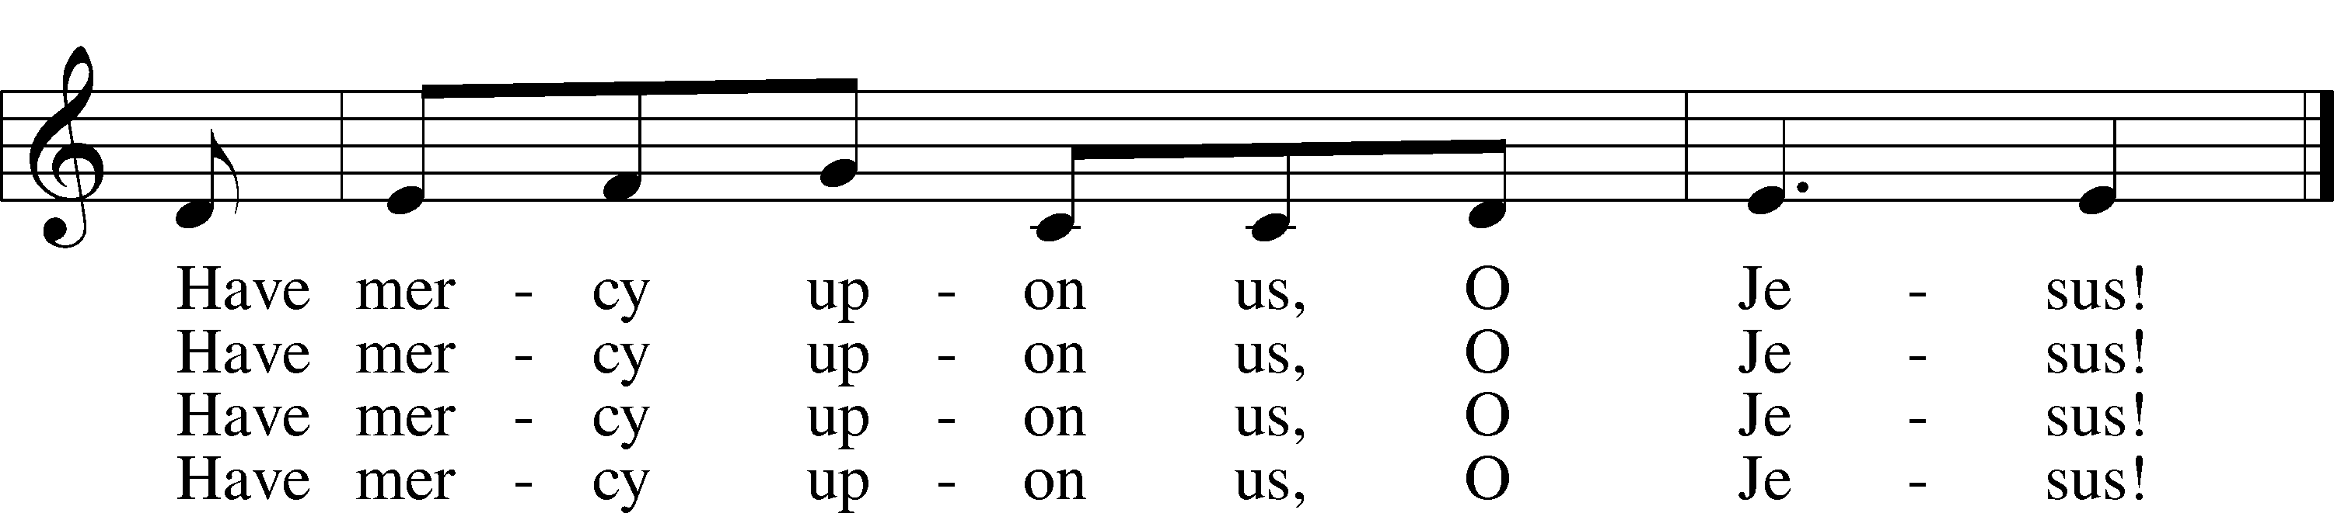
Text: Magnus Brostrup Landstad, 1802–80; tr. Peer O. Strömme, 1856–1921, adapt.
Tune: Swedish, 1694
Text and tune: Public domain

Sermon
Stand

Offertory LSB 192
C Create in me a clean heart, O God, and renew a right spirit within me.
Cast me not away from Thy presence, and take not Thy Holy Spirit from me.
Restore unto me the joy of Thy salvation, and uphold me with Thy free spirit. Amen.

Sit

Offering

Stand

Prayer of the Church

Service of the Sacrament

Preface LSB 194
P The Lord be with you.
C And with thy spirit.

P Lift up your hearts.
C We lift them up unto the Lord.

P Let us give thanks unto the Lord, our God.
C It is meet and right so to do.

P It is truly meet, right, and salutary that we should at all times and in all places give thanks to You, holy Lord, almighty Father, everlasting God, through Jesus Christ, our Lord. Therefore with angels and archangels and with all the company of heaven we laud and magnify Your glorious name, evermore praising You and saying:

Sanctus LSB 195
C Holy, holy, holy Lord God of Sabaoth;
heav’n and earth are full of Thy glory.
Hosanna, hosanna, hosanna in the highest.
Blessed is He, blessed is He, blessed is He that cometh in the name of the Lord.
Hosanna, hosanna, hosanna in the highest.

Lord’s Prayer LSB 196
P Our Father who art in heaven,
hallowed be Thy name,
Thy kingdom come,
Thy will be done on earth as it is in heaven;
give us this day our daily bread;
and forgive us our trespasses as we forgive those who trespass against us;
and lead us not into temptation,
but deliver us from evil.
C For Thine is the kingdom and the power and the glory forever and ever. Amen.

The Words of Our Lord LSB 197
P Our Lord Jesus Christ, on the night when He was betrayed, took bread, and when He had given thanks, He broke it and gave it to the disciples and said: “Take, eat; this is My T body, which is given for you. This do in remembrance of Me.”

In the same way also He took the cup after supper, and when He had given thanks, He gave it to them, saying: “Drink of it, all of you; this cup is the new testament in My T blood, which is shed for you for the forgiveness of sins. This do, as often as you drink it, in remembrance of Me.”

Pax Domini LSB 197
P The peace of the Lord be with you always.
C Amen.

Agnus Dei LSB 198
C O Christ, Thou Lamb of God, that takest away the sin of the world, have mercy upon us.
O Christ, Thou Lamb of God, that takest away the sin of the world, have mercy upon us.
O Christ, Thou Lamb of God, that takest away the sin of the world, grant us Thy peace. Amen.

Sit

Distribution
We ordinarily offer the Lord’s Supper only to those who are communicant members of a congregation of the Lutheran Church-Missouri Synod or of congregations which are part of a church body which is in altar or pulpit fellowship with the LCMS. The Scriptures teach that Holy Communion is to be a confession of a common faith (1 Cor. 10:17, Acts 2:42) and that those who are unprepared may even do themselves spiritual harm (1 Cor. 11:23-32). We do not hereby presume to question another’s faith in Christ, but hold this historic position out of love for God’s Word and in care for souls. Inviting all Christians to Communion would imply a oneness which does not yet exist but for which we must all pray. Even as we try to respect the practices of other Christian denominations so we ask others to respect our practice. Those who would like to discuss this practice at more length may make an appointment with our pastor to do so.
If you are unable to receive Holy Communion, but wish to receive a blessing, please feel free to come forward. Please stand with your hands behind your back to indicate that you would like a blessing.

633 At the Lamb’s High Feast We Sing
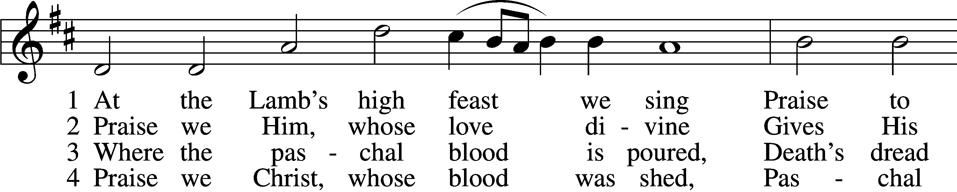
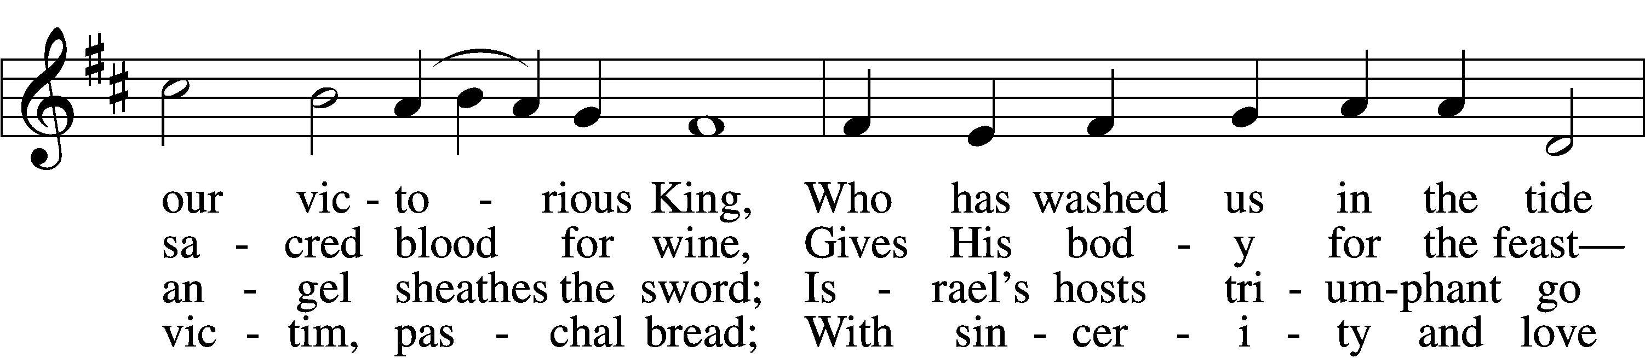
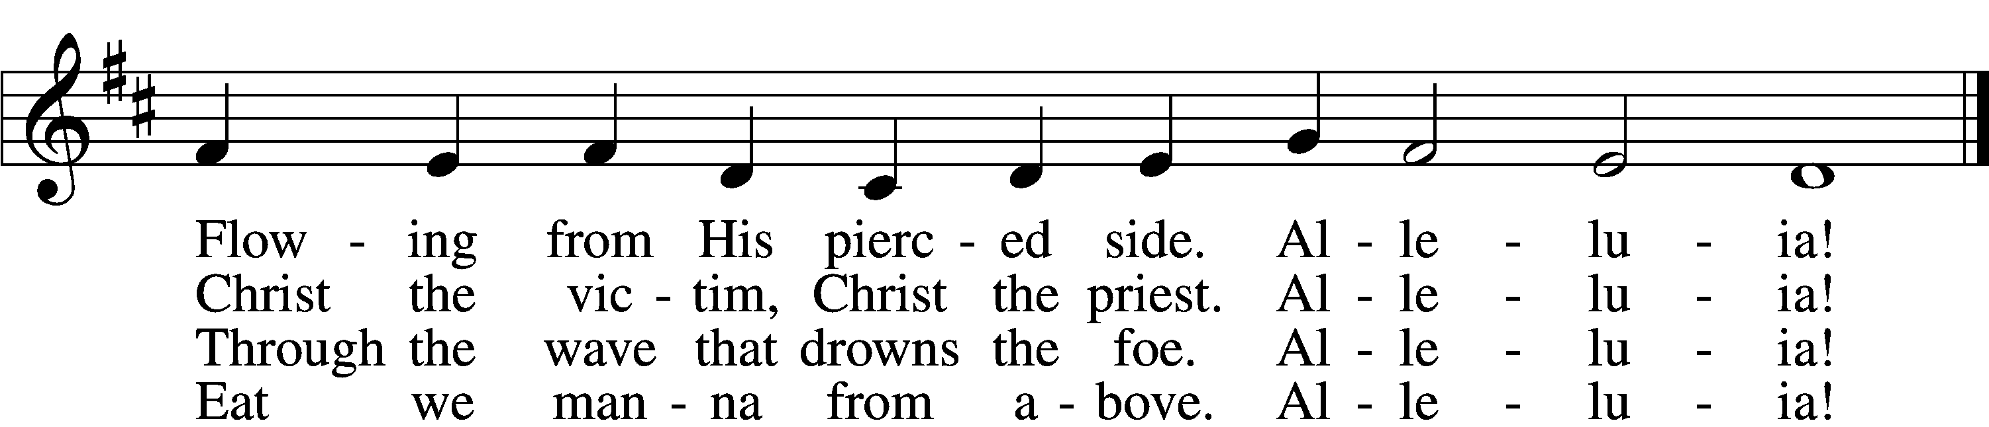

5 Mighty Victim from the sky,
Hell’s fierce pow’rs beneath You lie;
You have conquered in the fight,
You have brought us life and light.
Alleluia!

6 Now no more can death appall,
Now no more the grave enthrall;
You have opened paradise,
And Your saints in You shall rise.
Alleluia!

7 Easter triumph, Easter joy!
This alone can sin destroy;
From sin’s pow’r, Lord, set us free,
Newborn souls in You to be.
Alleluia!

D 8 Father, who the crown shall give,
Savior, by whose death we live,
Spirit, guide through all our days:
Three in One, Your name we praise.
Alleluia!
Text: Latin, c. 5th–10th cent.; tr. Robert Campbell, 1814–68, alt.
Tune: Kirchengeseng, 1566, Ivancice
Text and tune: Public domain

636 Soul, Adorn Yourself with Gladness
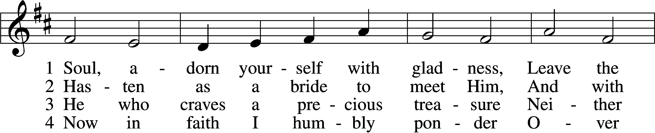
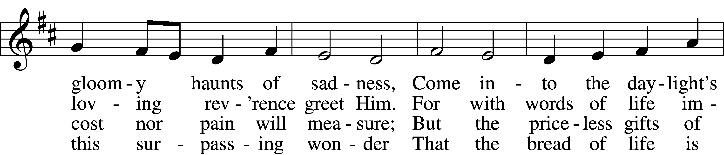
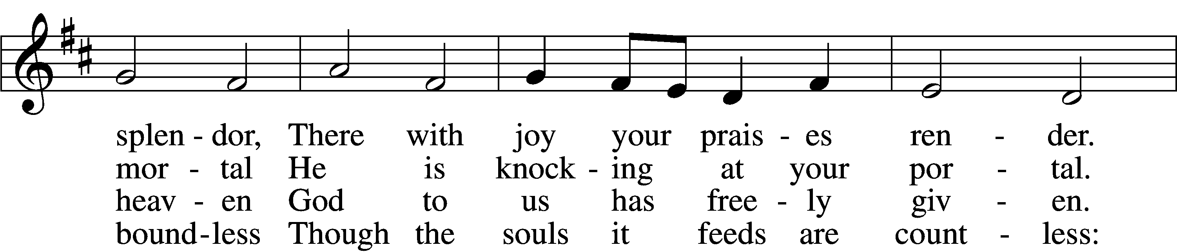
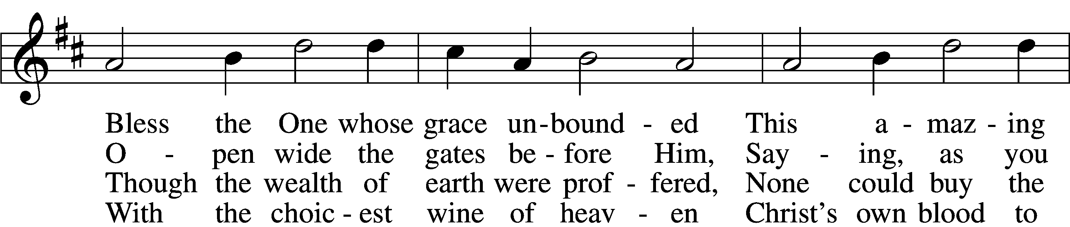
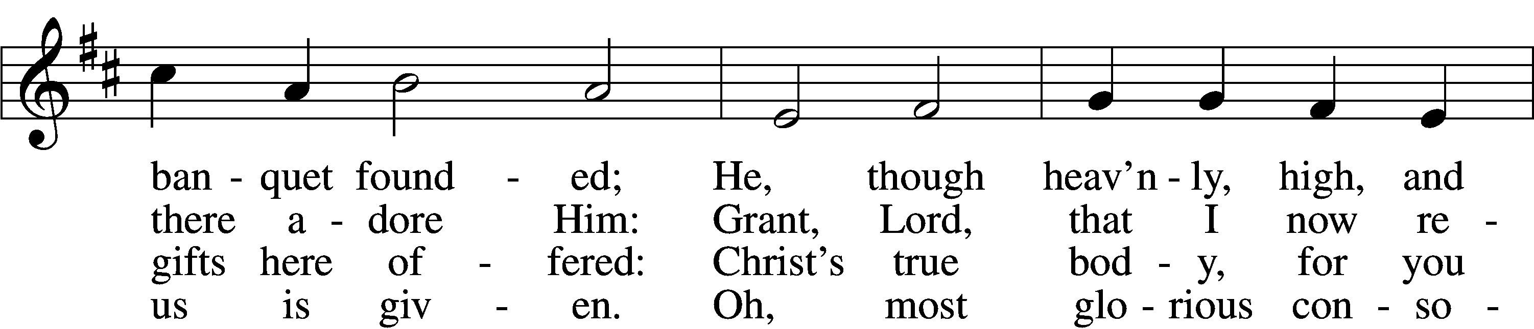
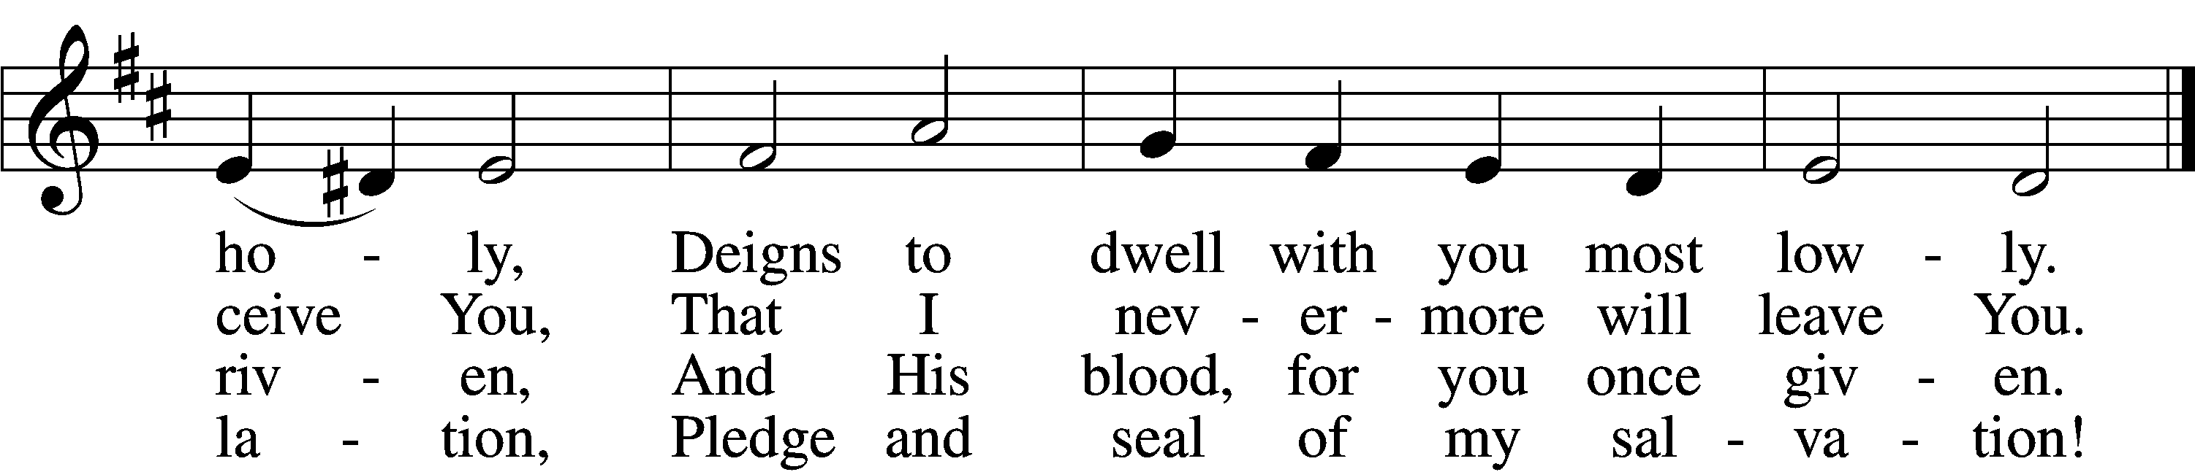

5 Jesus, source of lasting pleasure,
Truest friend, and dearest treasure,
Peace beyond all understanding,
Joy into all life expanding:
Humbly now, I bow before You;
Love incarnate, I adore You;
Worthily let me receive You
And, so favored, never leave You.

6 Jesus, sun of life, my splendor,
Jesus, friend of friends, most tender,
Jesus, joy of my desiring,
Fount of life, my soul inspiring:
At Your feet I cry, my maker,
Let me be a fit partaker
Of this blessèd food from heaven,
For our good, Your glory, given.

7 Lord, by love and mercy driven,
You once left Your throne in heaven
On the cross for me to languish
And to die in bitter anguish,
To forego all joy and gladness
And to shed Your blood in sadness.
By this blood redeemed and living,
Lord, I praise You with thanksgiving.

8 Jesus, bread of life, I pray You,
Let me gladly here obey You.
By Your love I am invited,
Be Your love with love requited;
By this Supper let me measure,
Lord, how vast and deep love’s treasure.
Through the gift of grace You give me
As Your guest in heav’n receive me.
Text: Johann Franck, 1618–77; (sts. 1, 4–5): tr. Lutheran Book of Worship, 1978; (sts. 2–3, 6–8): tr. Catherine Winkworth, 1827–78, alt.
Tune: Johann Crüger, 1598–1662
Text (sts. 1, 4–5): © 1978 Lutheran Book of Worship. Used by permission: LSB Hymn License no. 110001899
Text (sts. 2–3, 6–8) and tune: Public domain

Stand

Nunc Dimittis LSB 199
C Lord, now lettest Thou Thy servant depart in peace according to Thy word,
for mine eyes have seen Thy salvation, which Thou hast prepared before the face of all people,
a light to lighten the Gentiles and the glory of Thy people Israel.
Glory be to the Father and to the Son and to the Holy Ghost;
as it was in the beginning, is now, and ever shall be, world without end. Amen.

Thanksgiving LSB 200
A O give thanks unto the Lord, for He is good,
C and His mercy endureth forever.

A Let us pray.
We give thanks to You, almighty God, that You have refreshed us through this salutary gift, and we implore You that of Your mercy You would strengthen us through the same in faith toward You and in fervent love toward one another; through Jesus Christ, Your Son, our Lord, who lives and reigns with You and the Holy Spirit, one God, now and forever.
C Amen.

P The Lord be with you.
C And with thy spirit.

Benedicamus LSB 202
A Bless we the Lord.
C Thanks be to God.

Benediction LSB 202
P The Lord bless you and keep you.
The Lord make His face shine upon you and be gracious unto you.
The Lord lift up His countenance upon you and ✠ give you peace.
C Amen, amen, amen.

Acknowledgments
Divine Service, Setting Three from Lutheran Service Book
Unless otherwise indicated, Scripture quotations are from the ESV® Bible (The Holy Bible, English Standard Version®), copyright © 2001 by Crossway, a publishing ministry of Good News Publishers. Used by permission. All rights reserved.
Created by Lutheran Service Builder © 2026 Concordia Publishing House.

In our prayers we pray for John Ireland and Amy Dickmander who are undergoing treatments for cancer.

Upcoming Events!

October 11 at 6:30 PM

Monthly Game Night

October 18 at 1:00 PM

Gather at the Chapel for a trip to Wilson’s Orchard.

October 23-24 – Women’s Retreat at Camp Io-Dis-E-Ca

Location: Camp Io-Dis-E-Ca, 3271 Sandy Beach Rd NE, Solon, IA 52333

Join us as Sofia van Hattem, MA presents on "Pardon and Power for the Christian Life: The Role of Grace in Your Life."

Originally from Antwerp, Belgium, Sofia received her Master of Arts in Spiritual Care from Concordia Seminary, St. Louis in 2026. Growing up in a pastor's family, she has been involved in the life and ministry of the Church from an early age. She has worked in the areas of worship & music leadership, youth faith formation, spiritual care & mercy work, event coordination & hospitality, administrative & organizational support, and cross-cultural ministry engagement.

With a heart for people and Christian formation, Sofia enjoys walking alongside others in their faith and exploring how God's Word shapes our everyday lives and relationships. At this retreat, we will reflect on God's grace as Sofia draws on her thesis on the role of grace in the Christian life.

Schedule:

Friday, October 23

6:00 PM - Arrive and get settled.

7:00 PM - Opening prayer

7:15 PM - Session 1

9:00 PM - Social Time

???? PM - Bed

Saturday, October 24

8:00 AM - Breakfast

8:45 AM - Prayer

9:00 AM - Session 2

10:30 AM - Camp activities

12:00 PM - Lunch

1:00 PM - Session 3

3:00 PM - Retreat officially ends

Your cost: $10

Sing-up on the sheet in the Happy Hour Room.

October 24-25 – Men’s Retreat at College Hill Lutheran Church

Location: College Hill Lutheran Church 2322 Olive St. Cedar Falls, IA.

Men’s and Women’s Nights will be held on Friday, October 30, at 6:00 PM

General Information

Cry Room: If you are in need of a place to go with your children during the service, please feel free to use the bell tower. You will still be able to hear the service from there. Also, there is a changing station in the women’s bathroom.

Bulletin Announcements: If you are in charge of an announcement for an event, please have it to the administrative assistant by 9:00 AM on the Thursday before the first Sunday you would like it to run. E-mail it to stpaulschapel.iowacity@gmail.com

Lost and Found! In the student center is a wicker storage cube which is the Chapel’s Lost and Found. Any items left in the Chapel will be placed in this container. At the end of each month, the bin will be emptied and its contents will be donated to Good Will. All Chapelites are strongly encouraged to check the Lost and Found periodically so we don’t donate something of yours!

Auto Debit Offering Option: If you would like to automate or update your existing auto-offering please visit https://stpaulic.com/giving/ or speak with Chapel Treasurer Samantha Zoske, treasurer.stpaul@gmail.com

Calendar

Calendar
11 Today Choir Rehearsal at 8:20 AM
Divine Service at 9:00 AM
Happy Hour
Bible class
Game Night at 6:30 PM

14 Wednesday Evening Prayer at 7:00 PM

Bible class at 7:30 PM

18 Sunday Choir Rehearsal at 8:20 AM
Divine Service at 9:00 AM
Happy Hour
Bible class
Wilson’s Orchard at 1:00 PM

Private absolution is available by appointment.

Contact Information:
St. Paul’s Lutheran Chapel, Lutheran Church - Missouri Synod
404 East Jefferson, Iowa City, IA 52245, (319) 337-3652 www.stpaulic.com
Rev. W. Max Mons, S.T.M.: wmaxmons@gmail.com
Peter Le Sage Administrative Assistant: stpaulschapel.iowacity@gmail.com

